How to set up and connect to our AWS Database:

Step 1: Go to <https://aws.amazon.com/>, and click sign in to the console to sign in as root user.

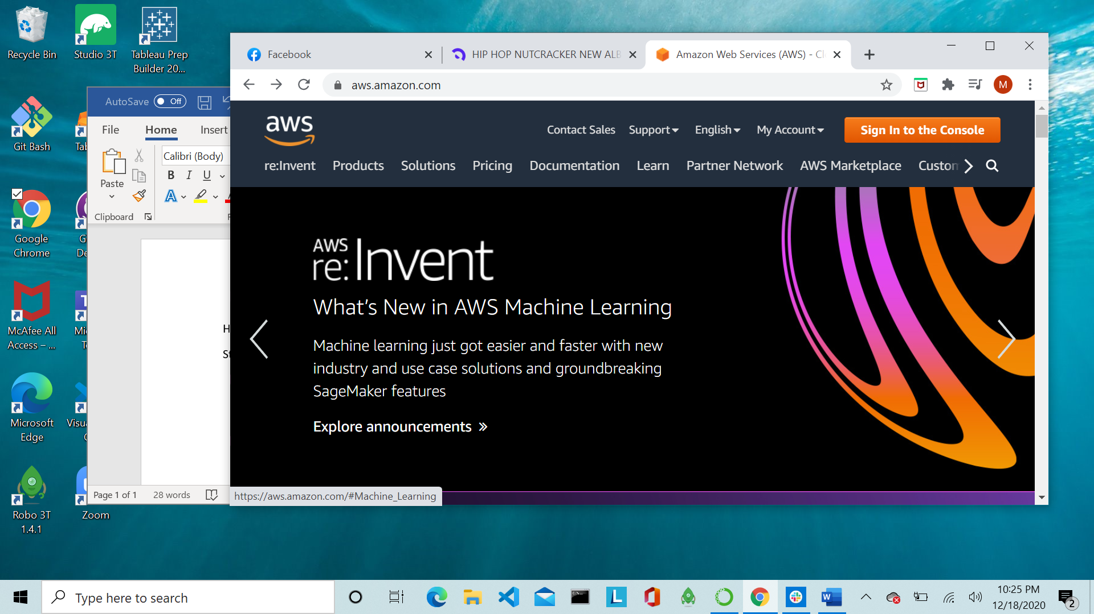



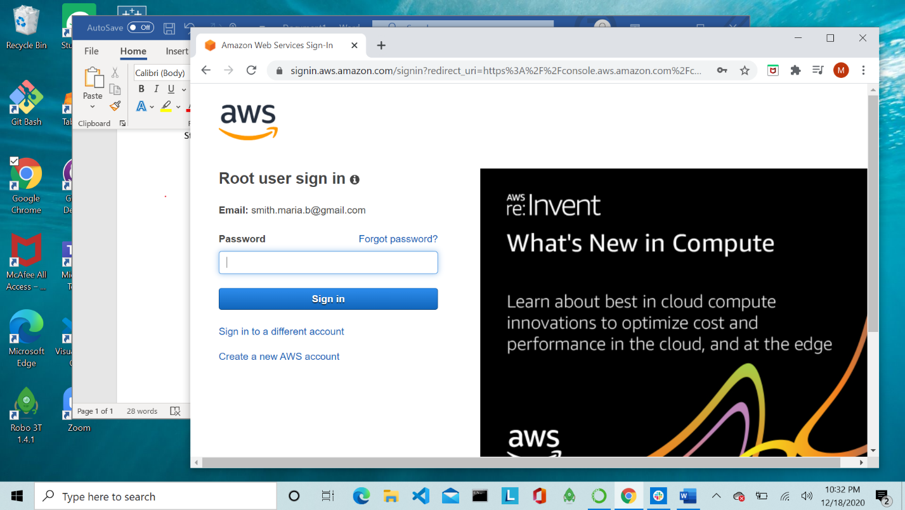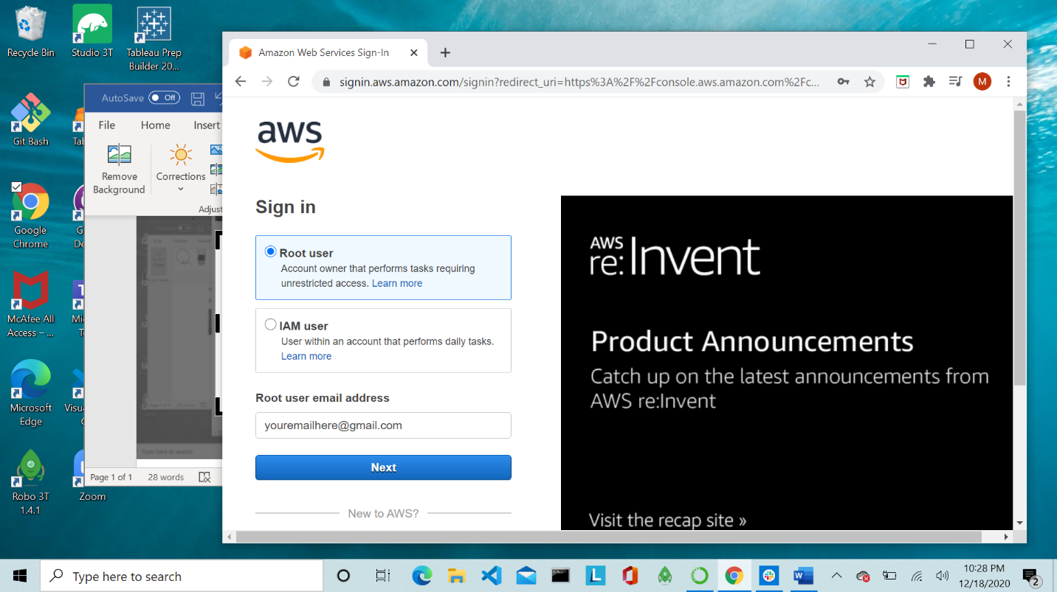



Step 2: Once you are logged in, click the dropdown that says services, and select RDS.

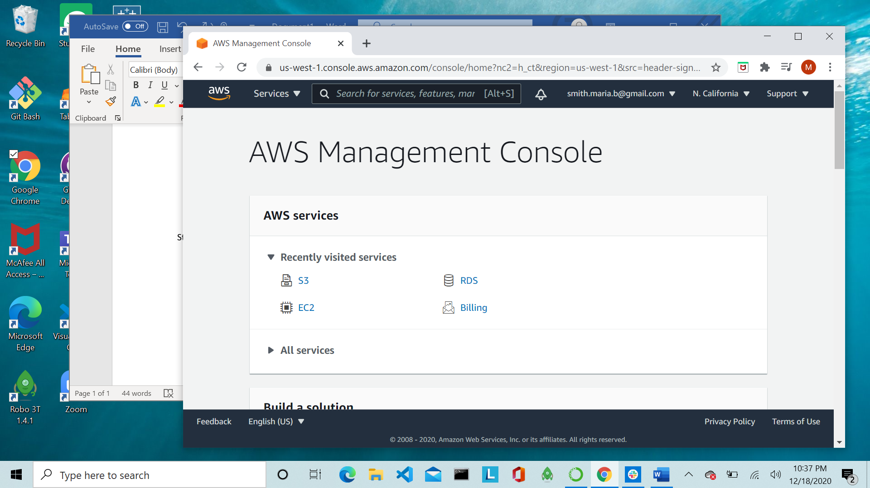



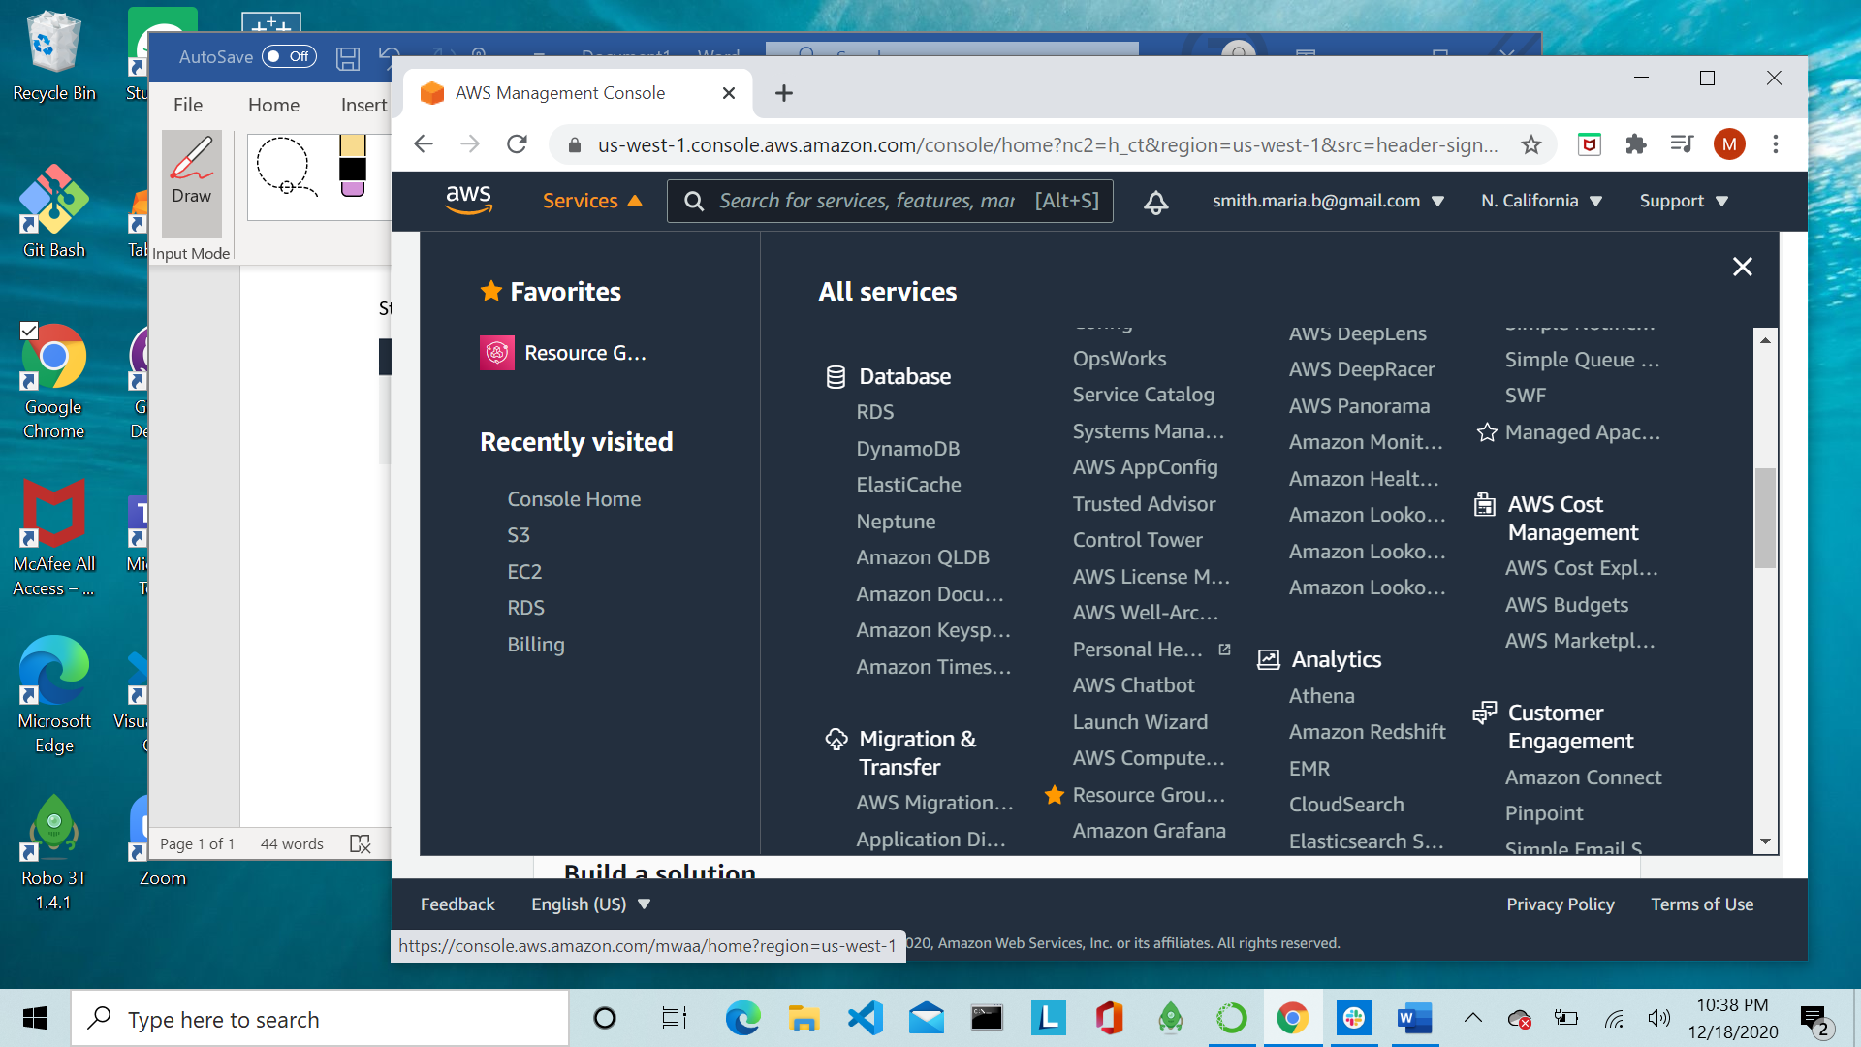

Step 3: Scroll down to find the option to create a database using the Amazon Relational Database Service (RDS) and click the create database button. \*

\*\*Make sure you are selecting the RDS database\*\*\*

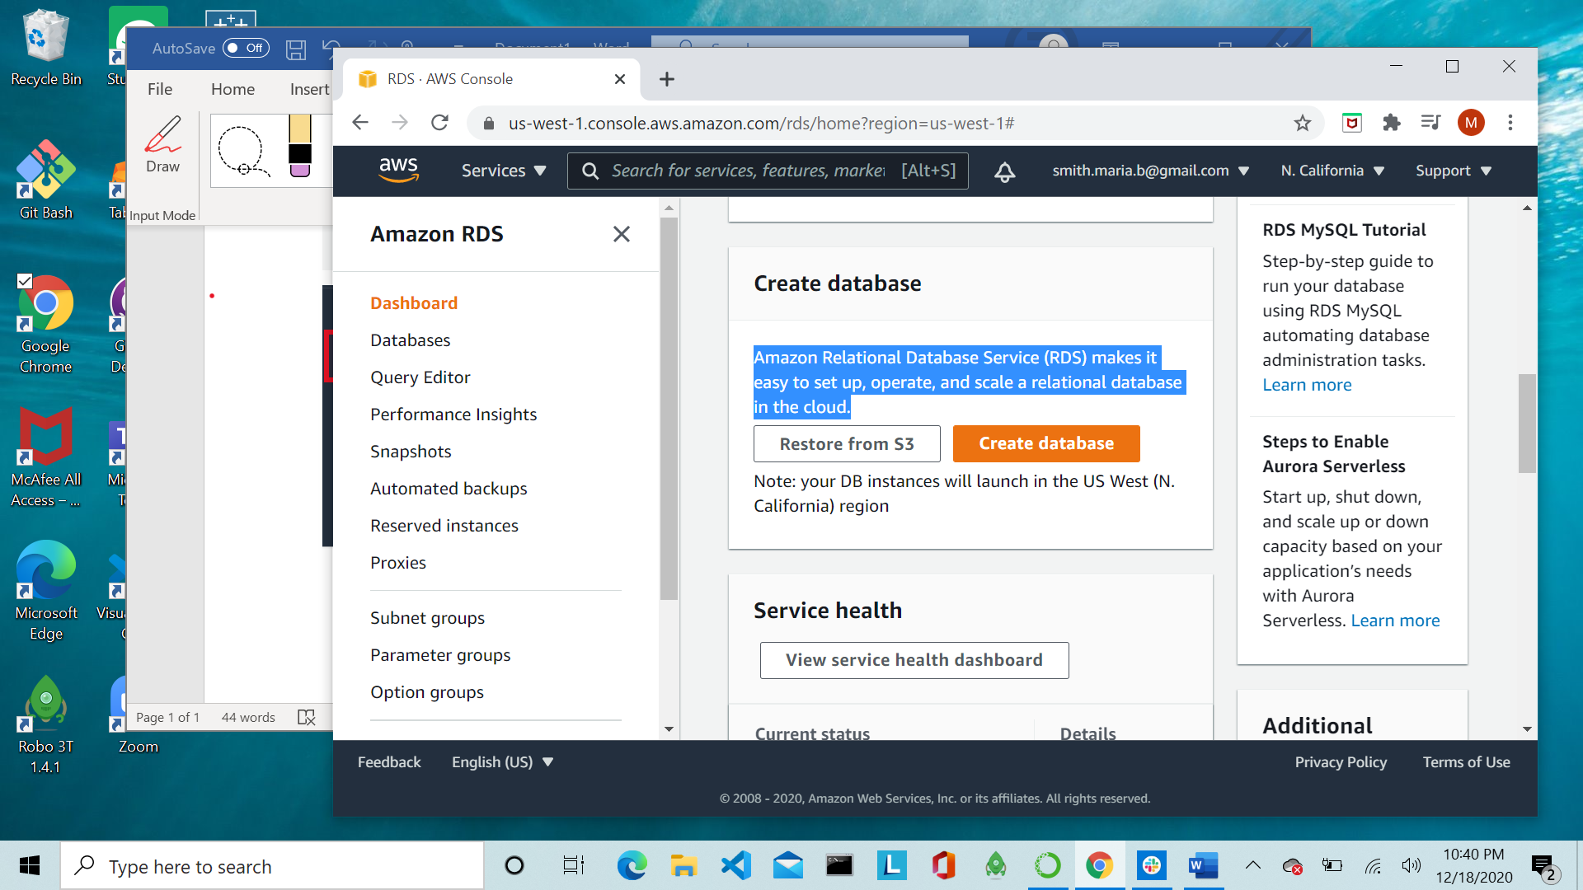

Step 4: Choose a database creation method: Standard Create

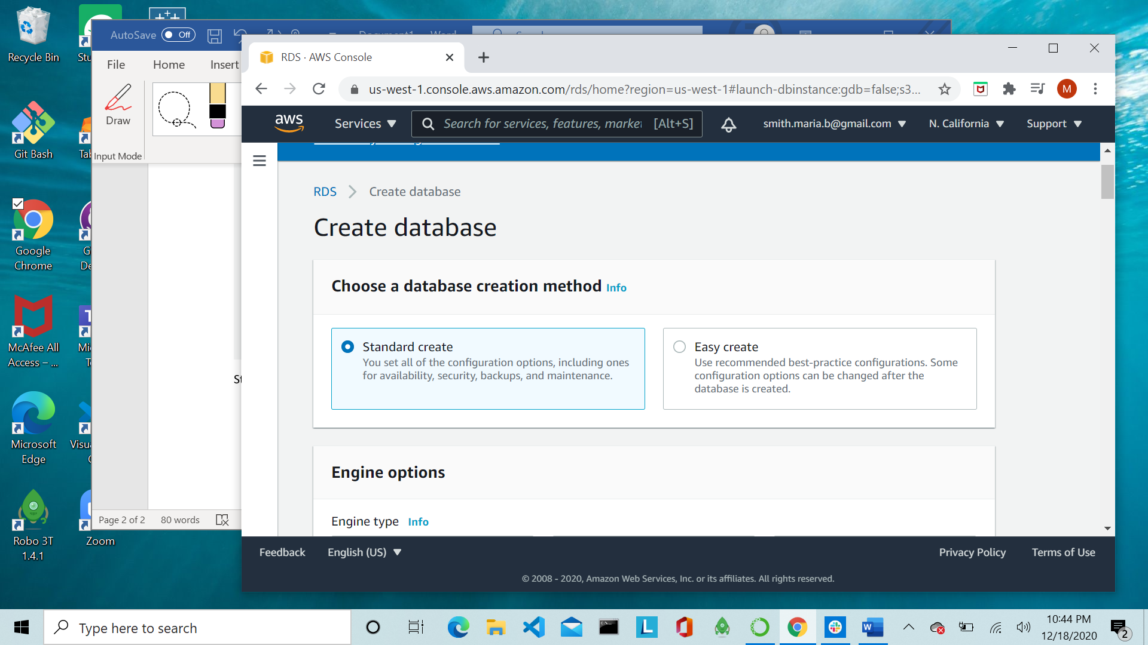

Step 5: Engine options: Select PostgresSQL and select the version running on your machine from the dropdown.

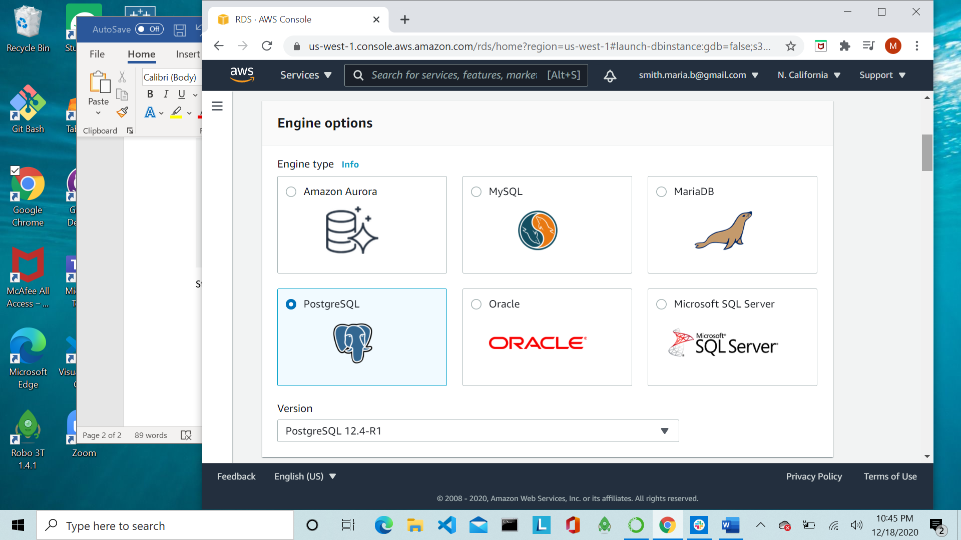

Step 6: Templates: Select the “Free Tier” option

Step 7: Settings: Assign your DB instance identifier, Master username and Master password. In our case the DB instance identifier and Master username are MUGSSProject3DB, and the Master password is data1234.

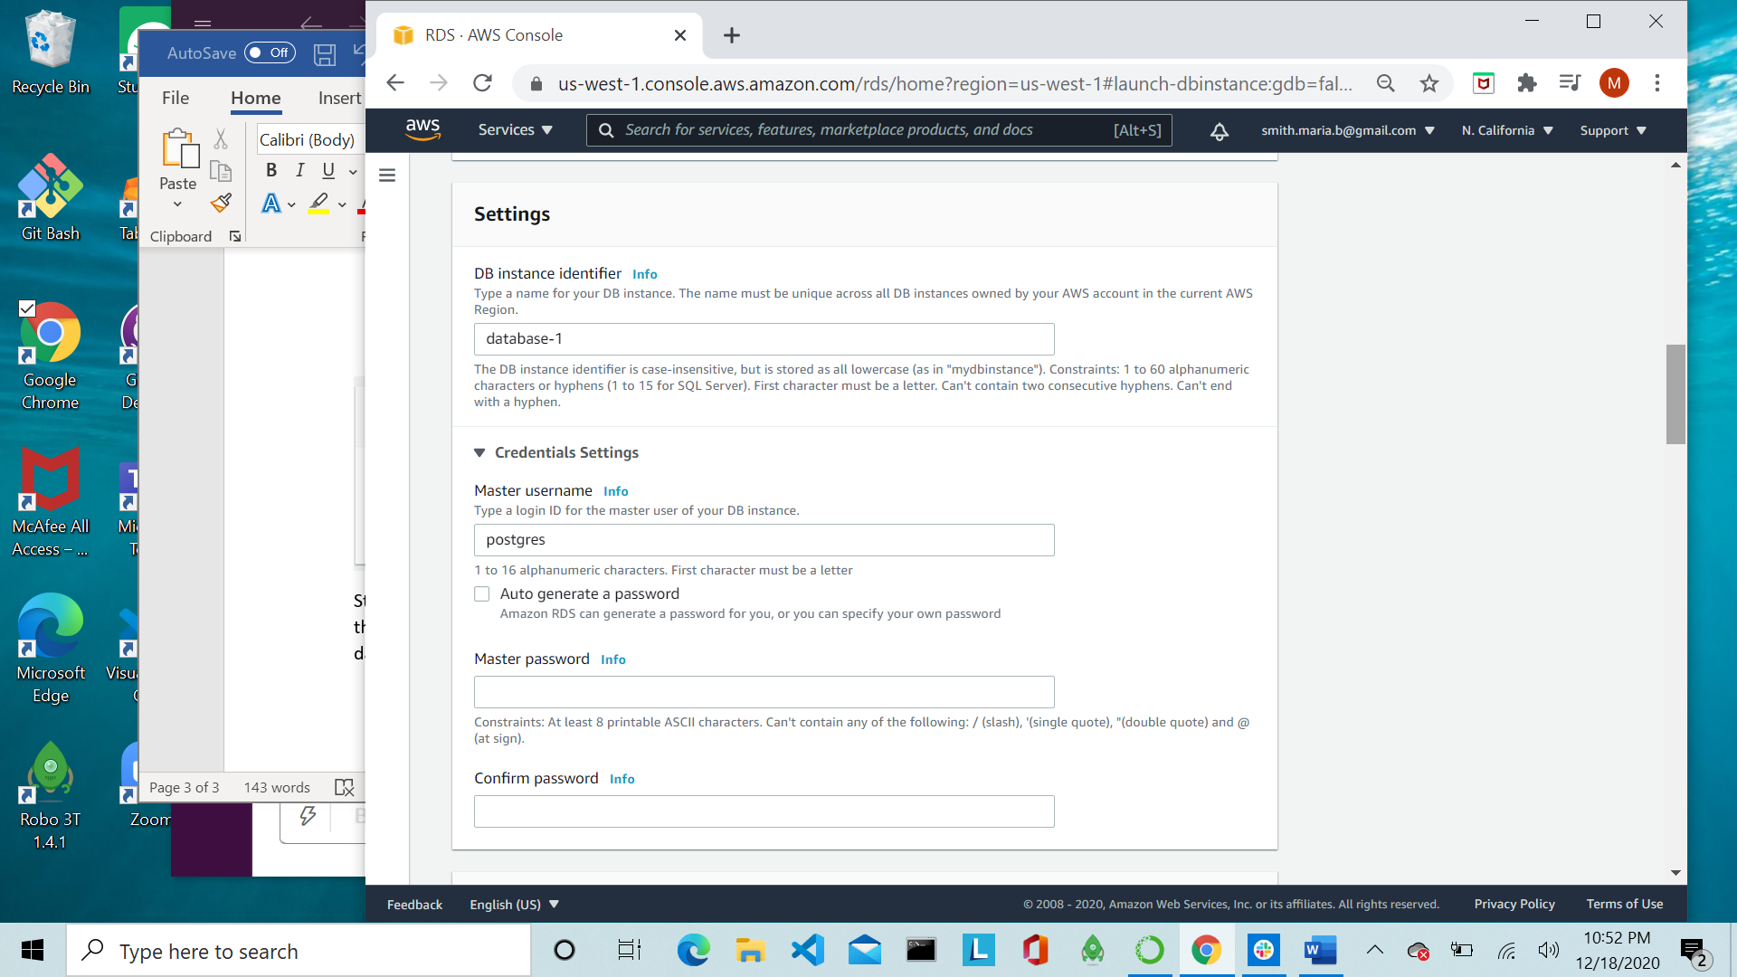

Step 8: Leave preferences for DB Instance Size, Storage and Availability & Durability unchanged

Step 9: Connectivity: Allow public access to the database and leave other options as default

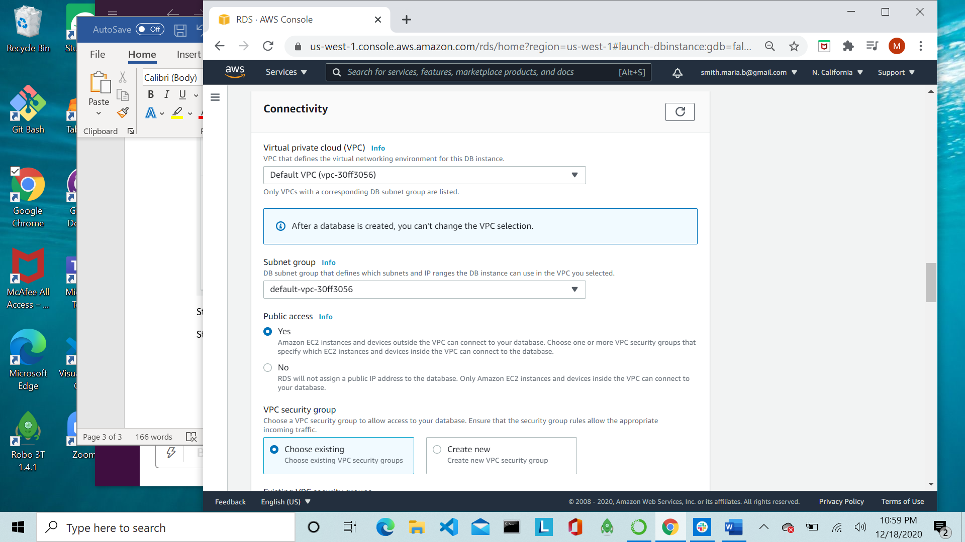

Step 10: Database authentication: Select “Password authentication”

Step 11: Additional Configuration: Make sure no additional options are checked.

Step 12: Select “Create database” at the bottom of the page. 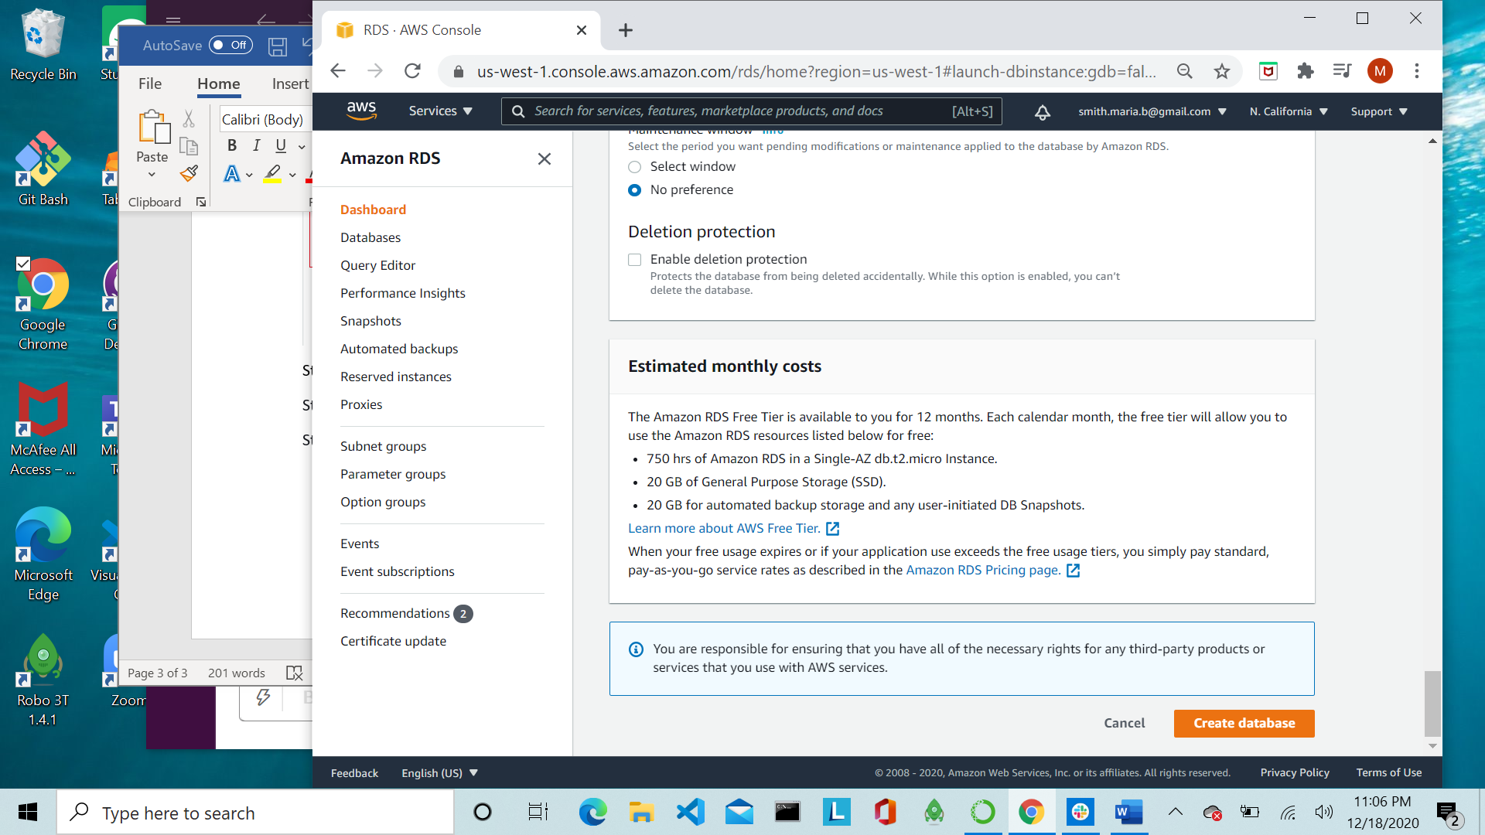

Step 13: Once DB is created, click the hyperlink to enter into the database

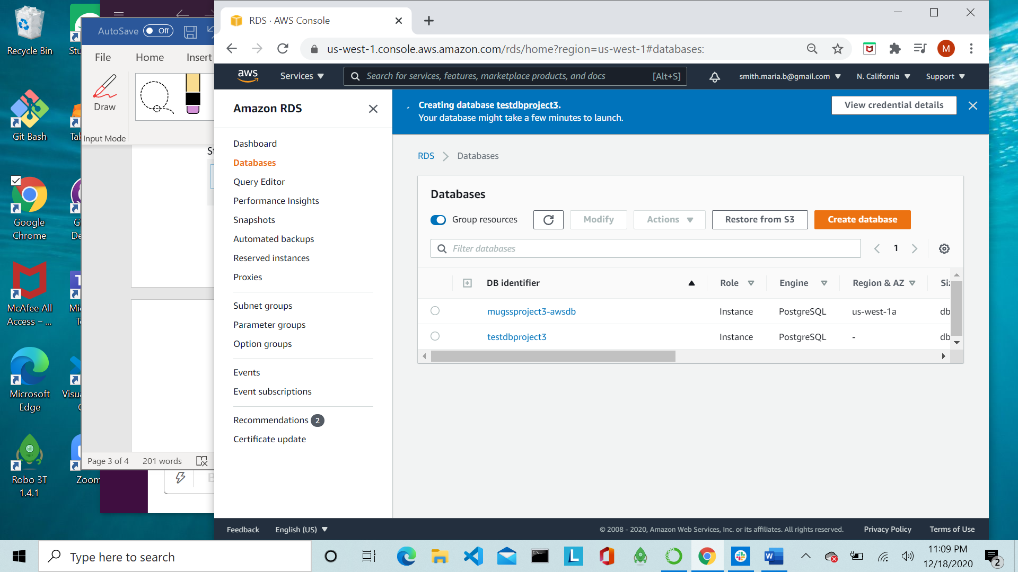

Step 14: Find the “Security group rules” section and confirm the inbound and outbound rule show 0.0.0.0/0. If they do not show 0.0.0.0/0 then click on the “Security group” hyperlink and complete steps 15-18. If they do, proceed to Step 19.

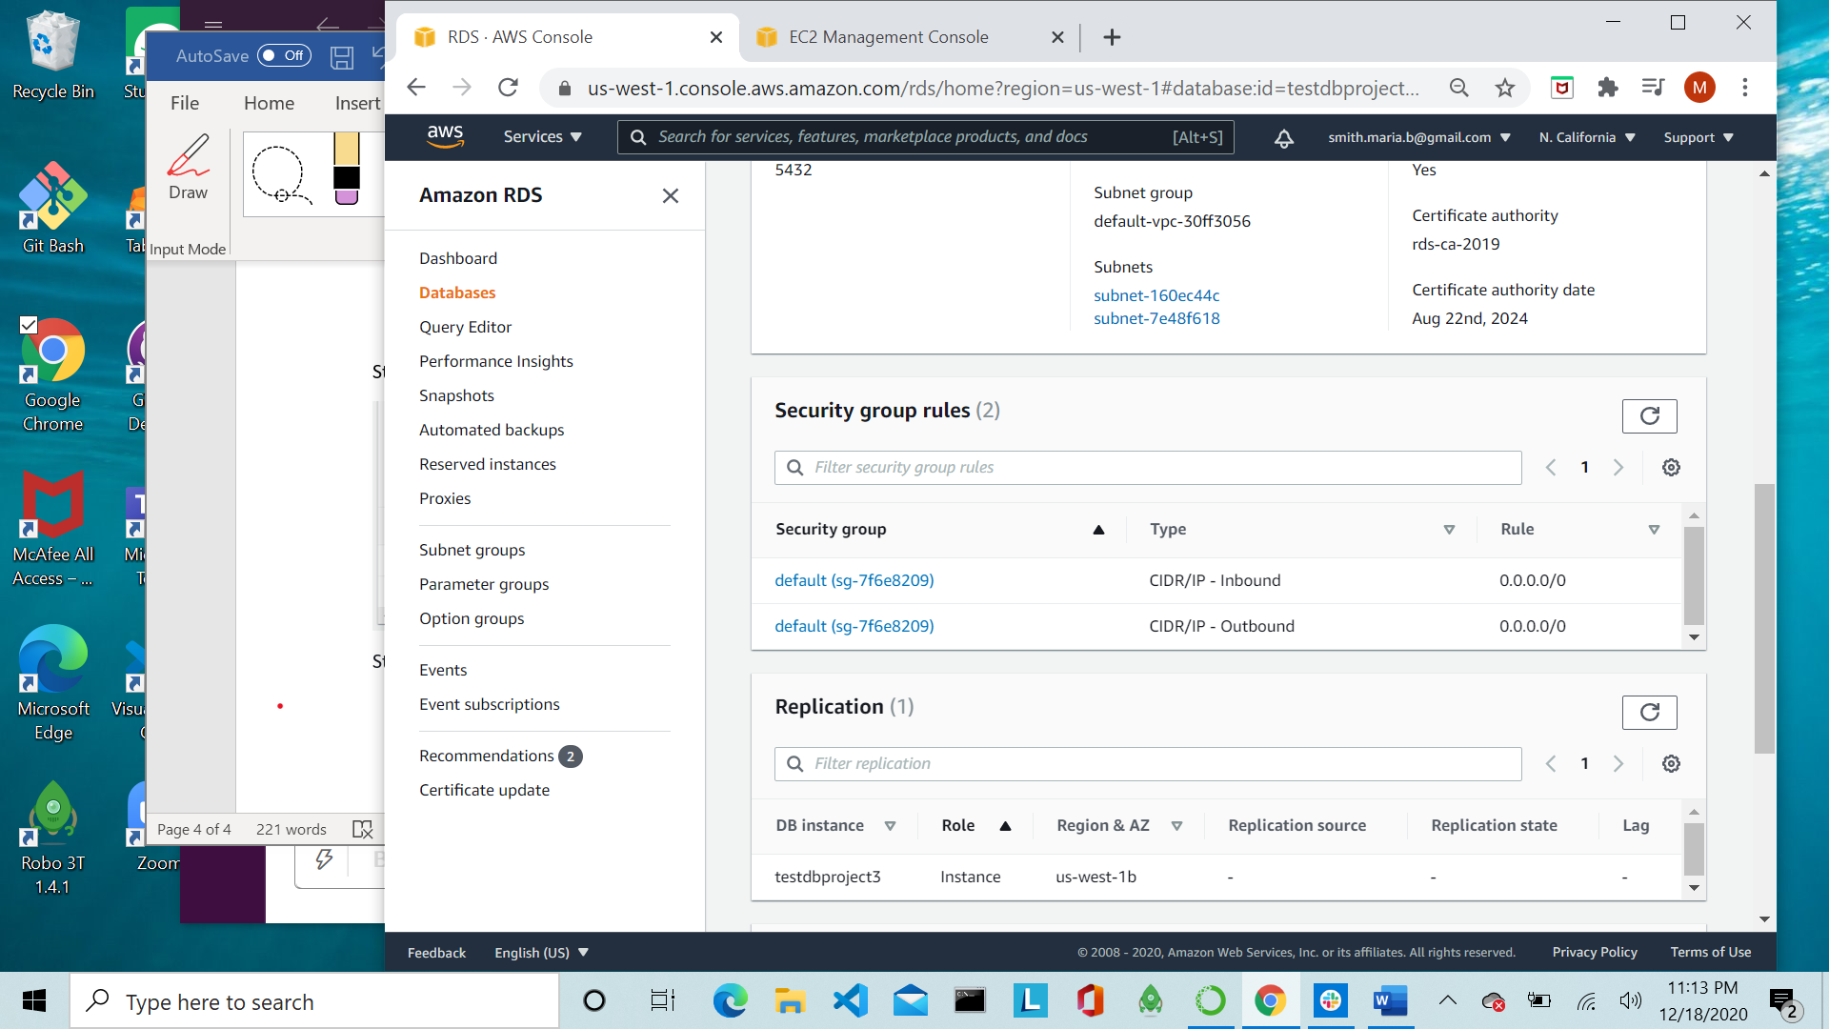

Step 15: Click on the “Security group ID”

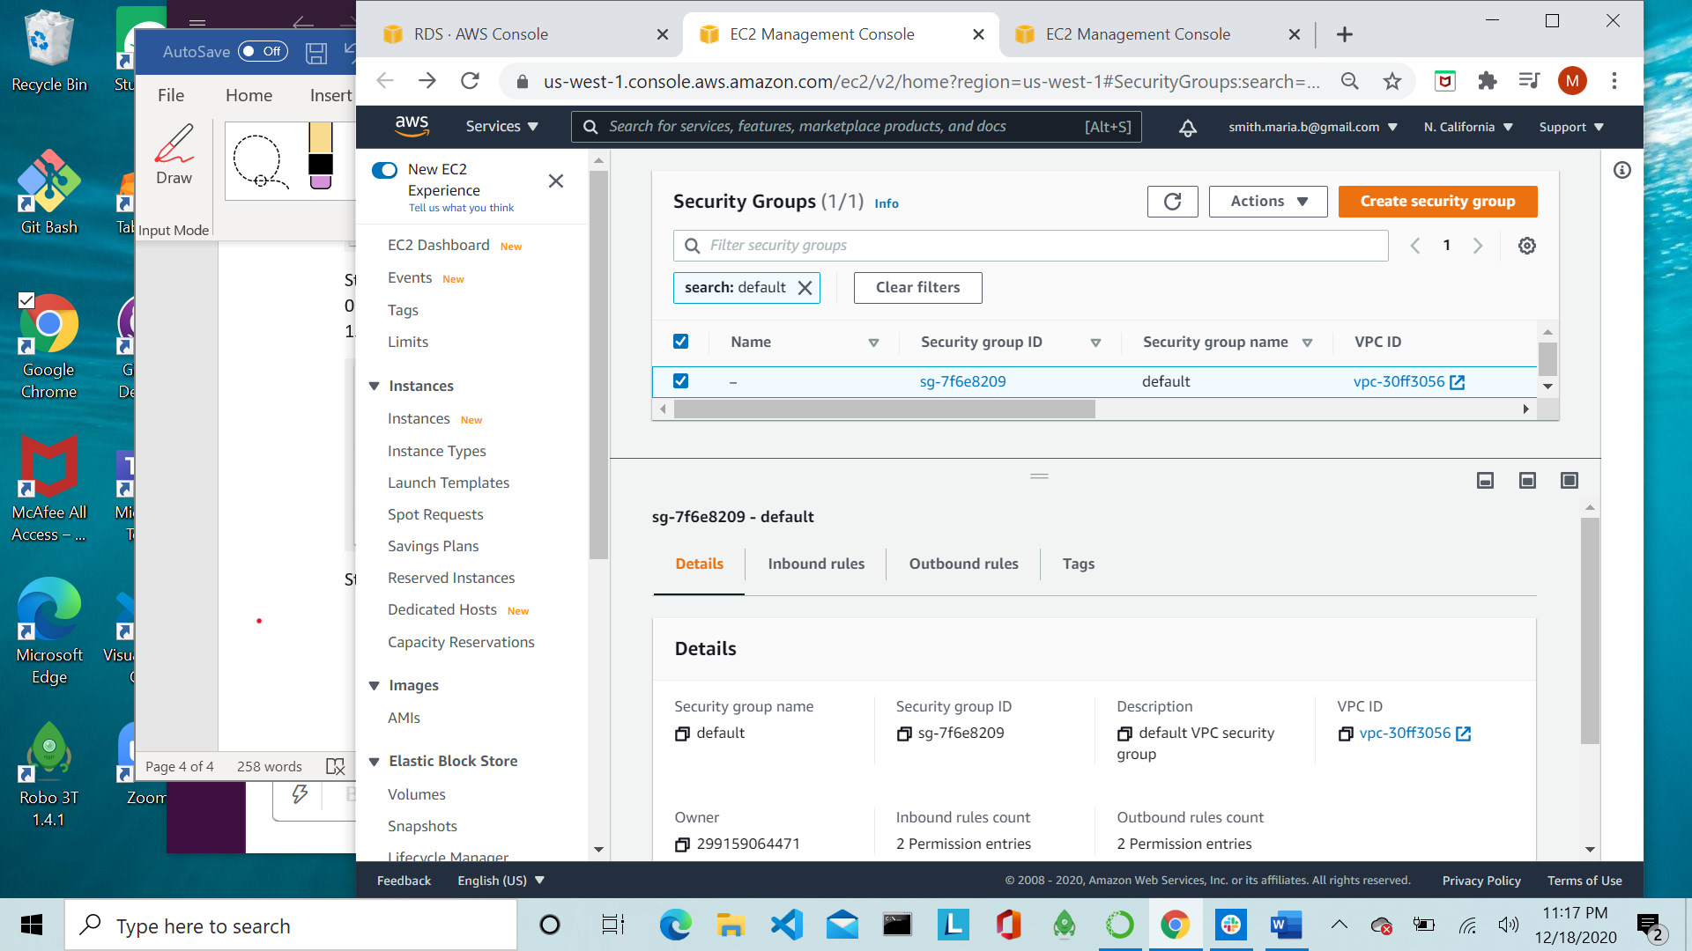

Step 16: Click on the “Edit inbound rules” button



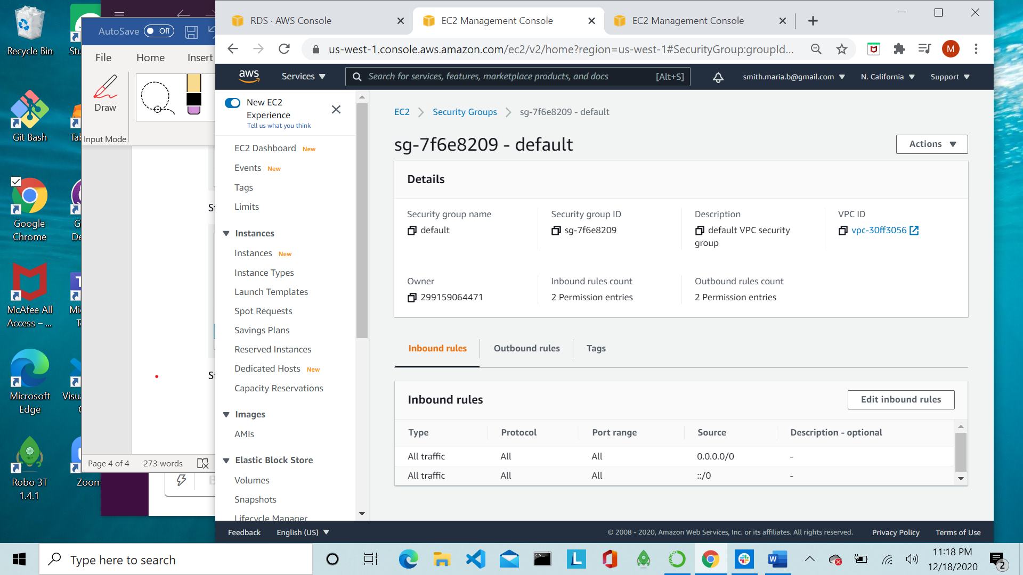

Step 17: Change the Source to “Anywhere” and click the “Save rules” button

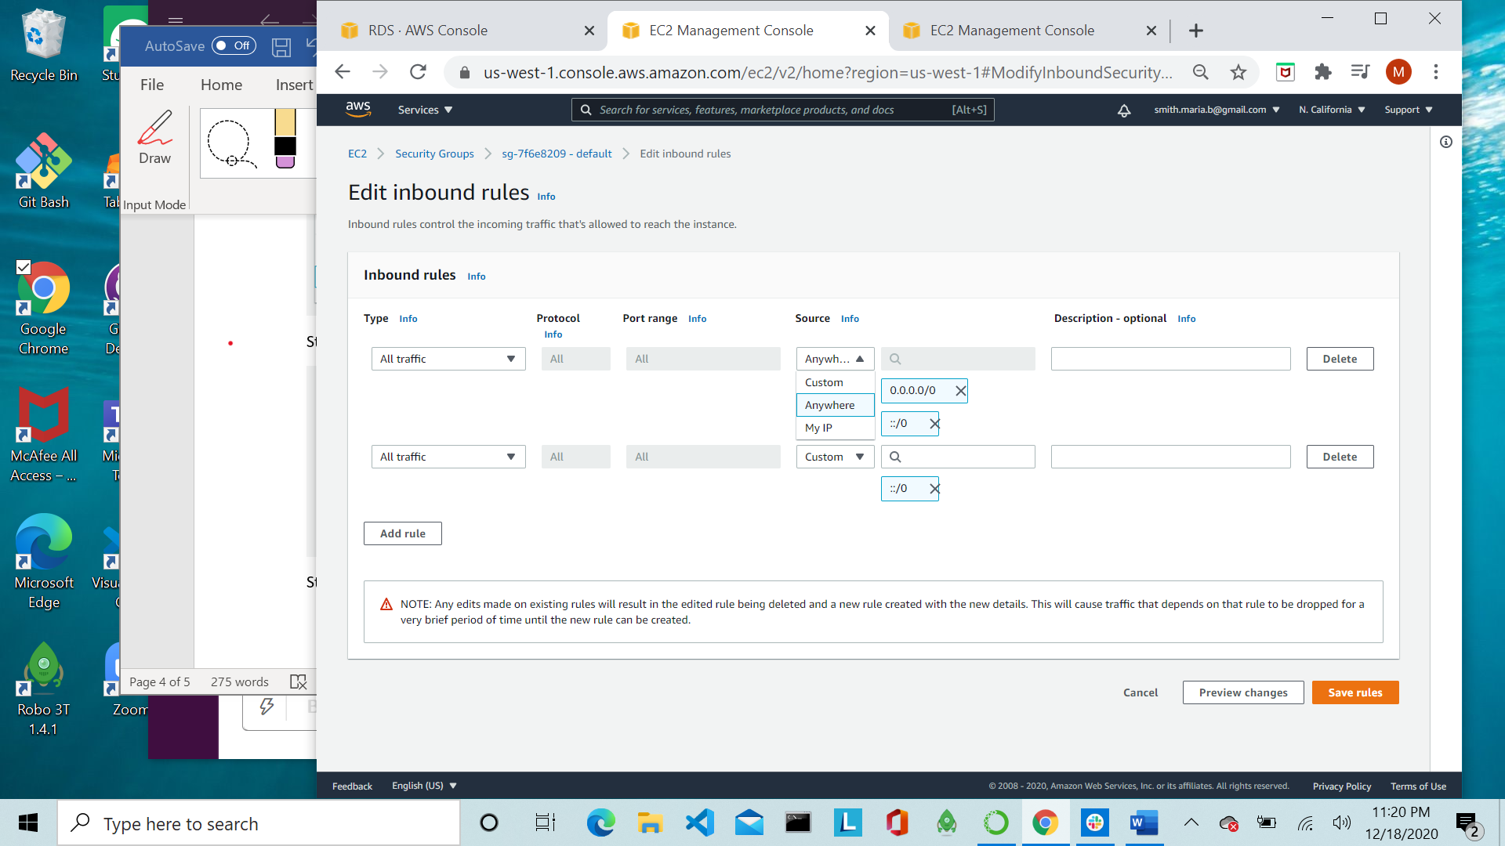

Step 18: Now select the Outbound rules tab and repeat steps 16 & 17 for the outbound rules.

Step 19: